Step3: Select “Add SVN Repository

tory” and enter the URL of the repository as**file:///C:\SVN\Mandatory**.  
The repository gets added to the SVN Repositories 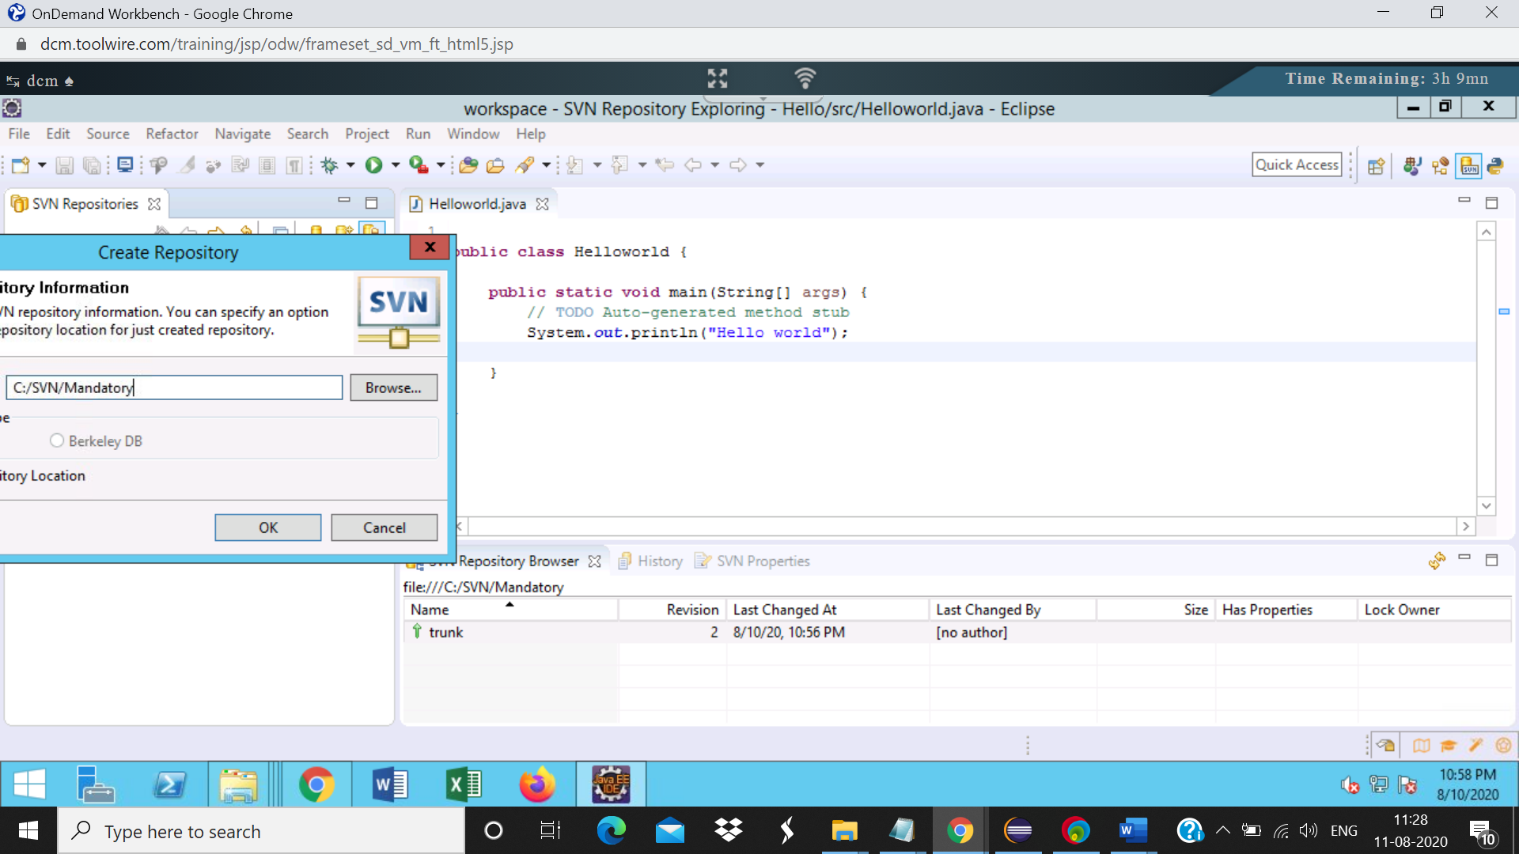

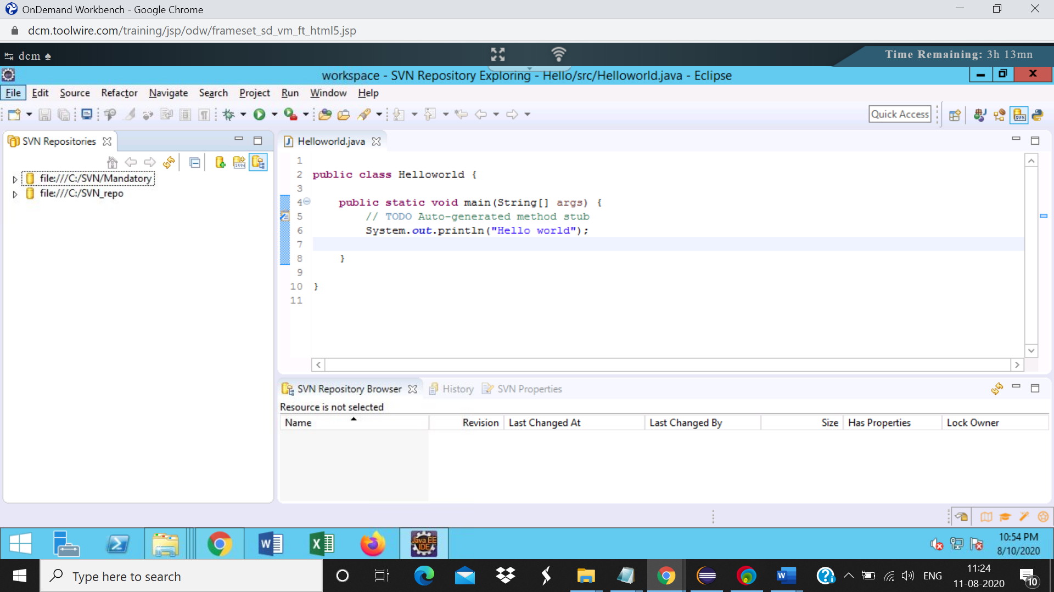

Step4: Right click on the **project10** inside trunk and select Checkout

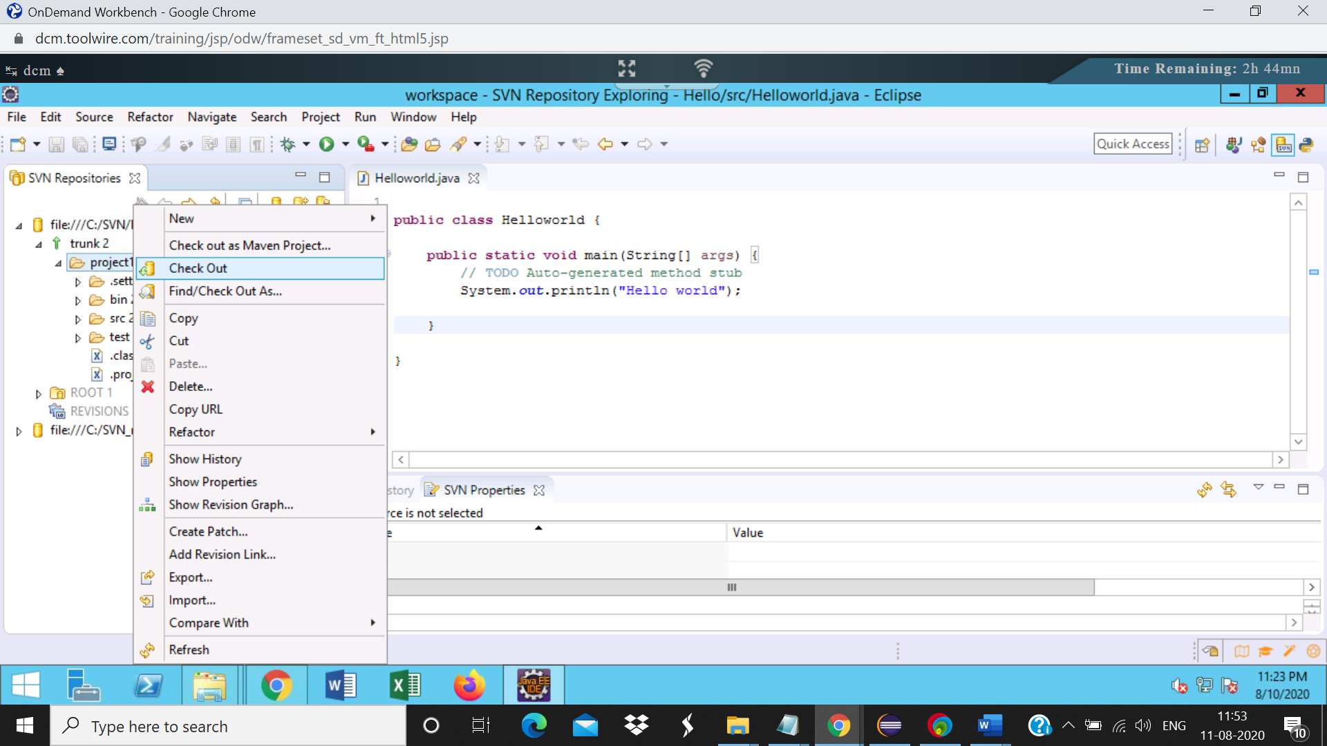

Step5:

Select “Check out as a project in the workspace” and specify the project name in the Checkout from SVN dialog.  
Click on Finish  
The project will be checked out to the workspace.  
Project name: Shipment_user1

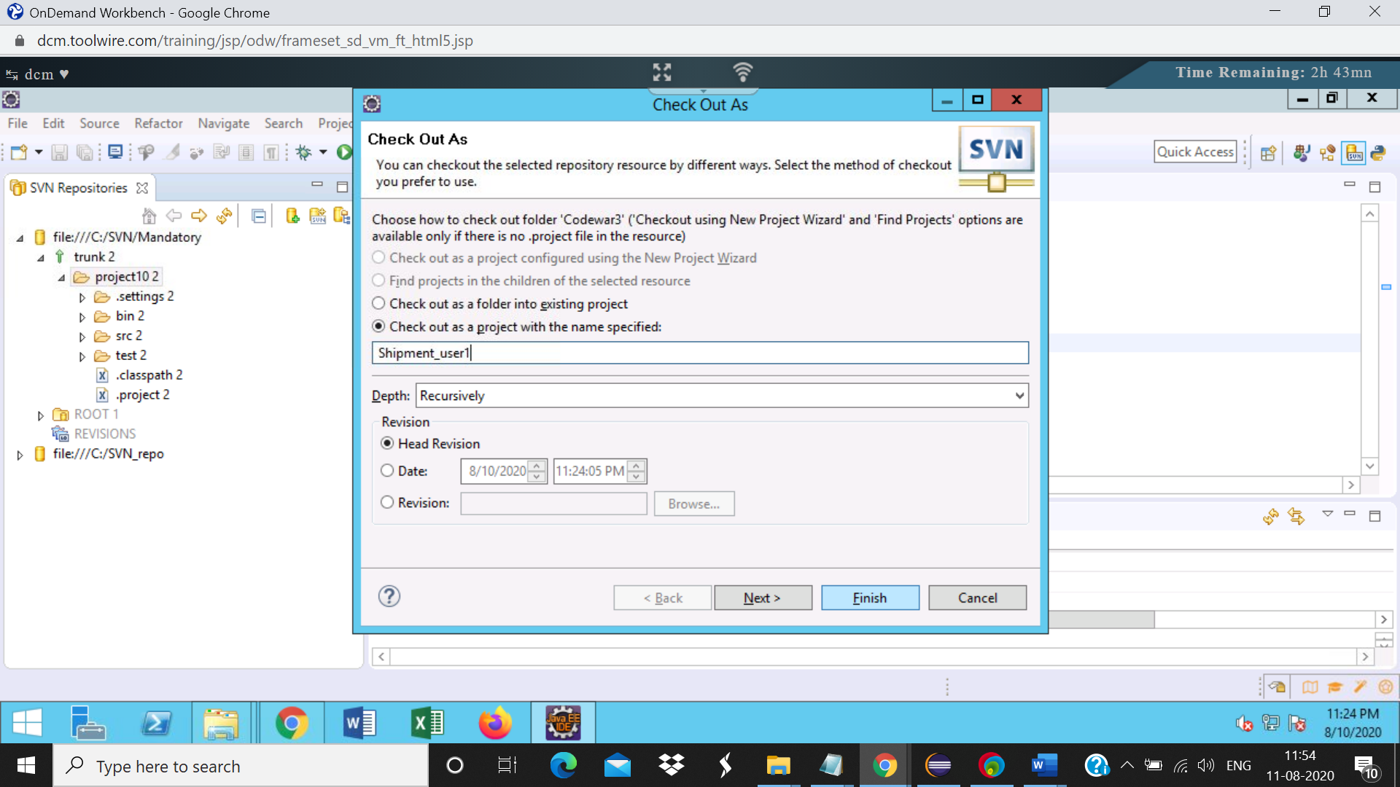

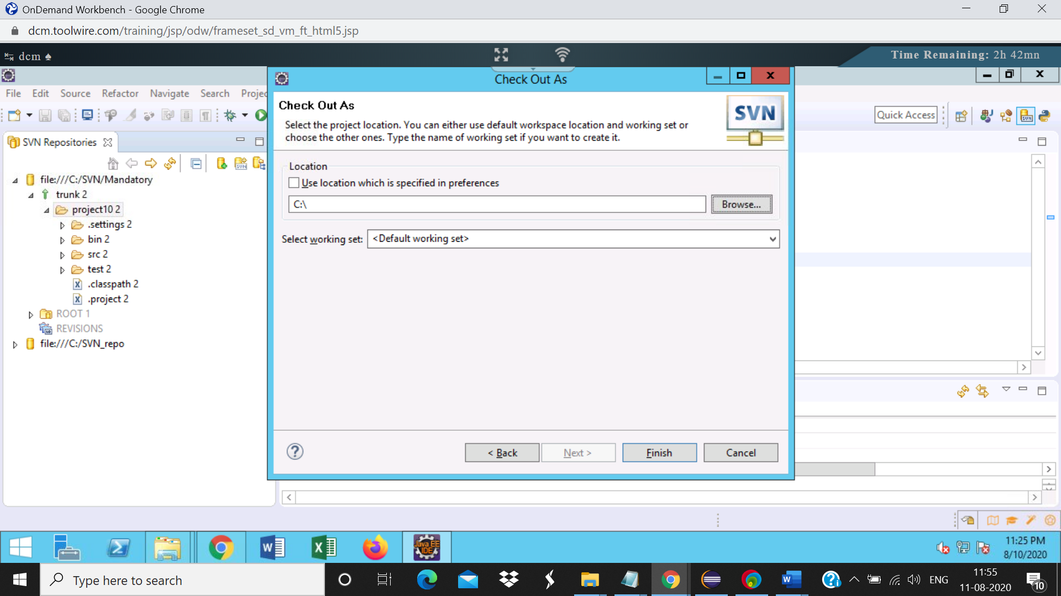

Screenshot of project explorer view

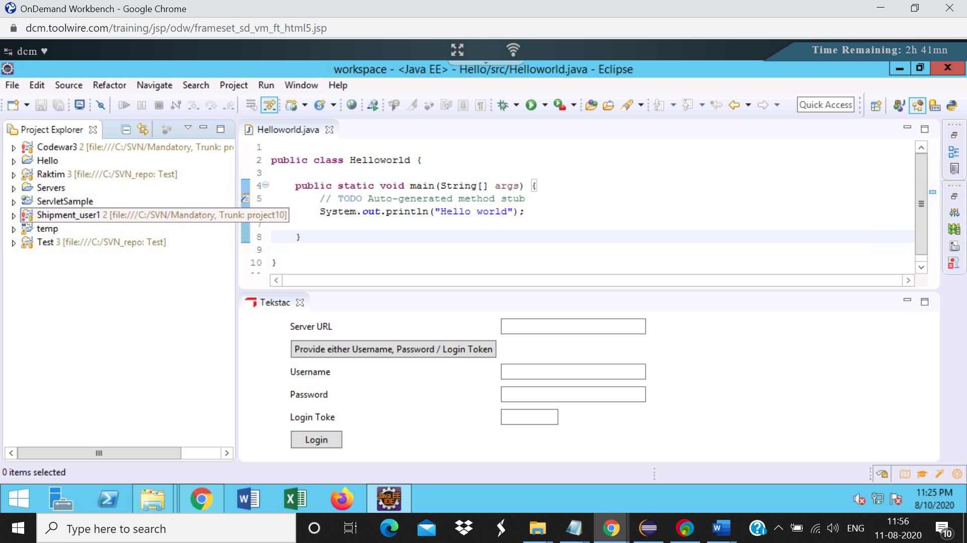

Step6:

In the SVN Repository, check out the same project again with a different name.  
Project name: Shipment_user2

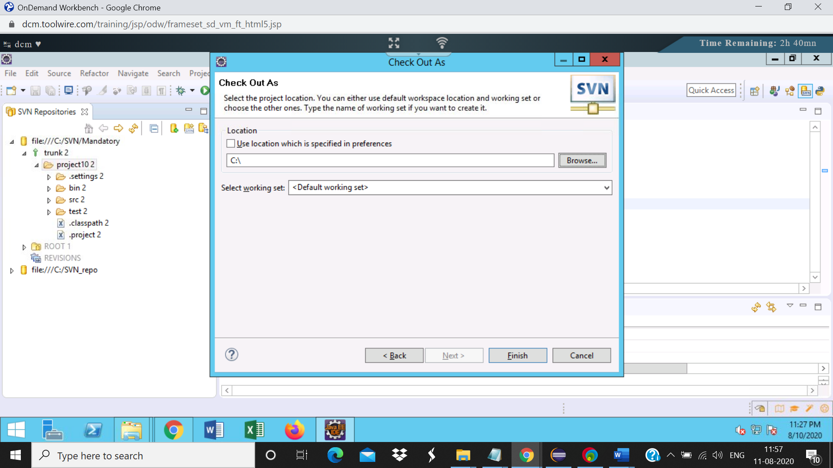

Project explorer view:

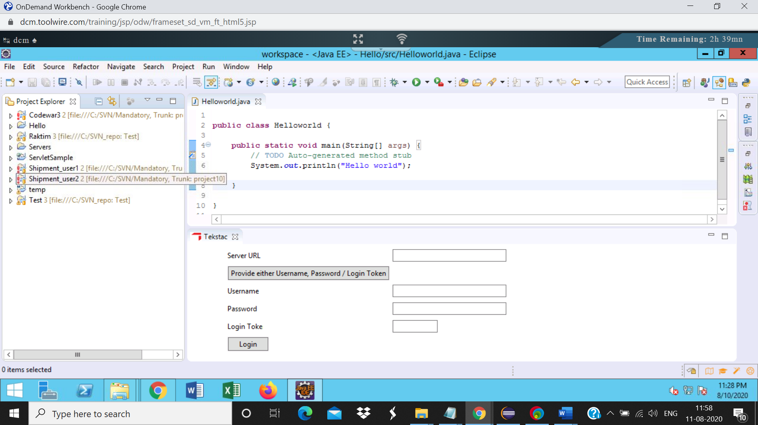

Step7:

In Shipment_user1 project, Modify the ShipmentStatus.java file, Update the variable name from id to shipmentID and save the file

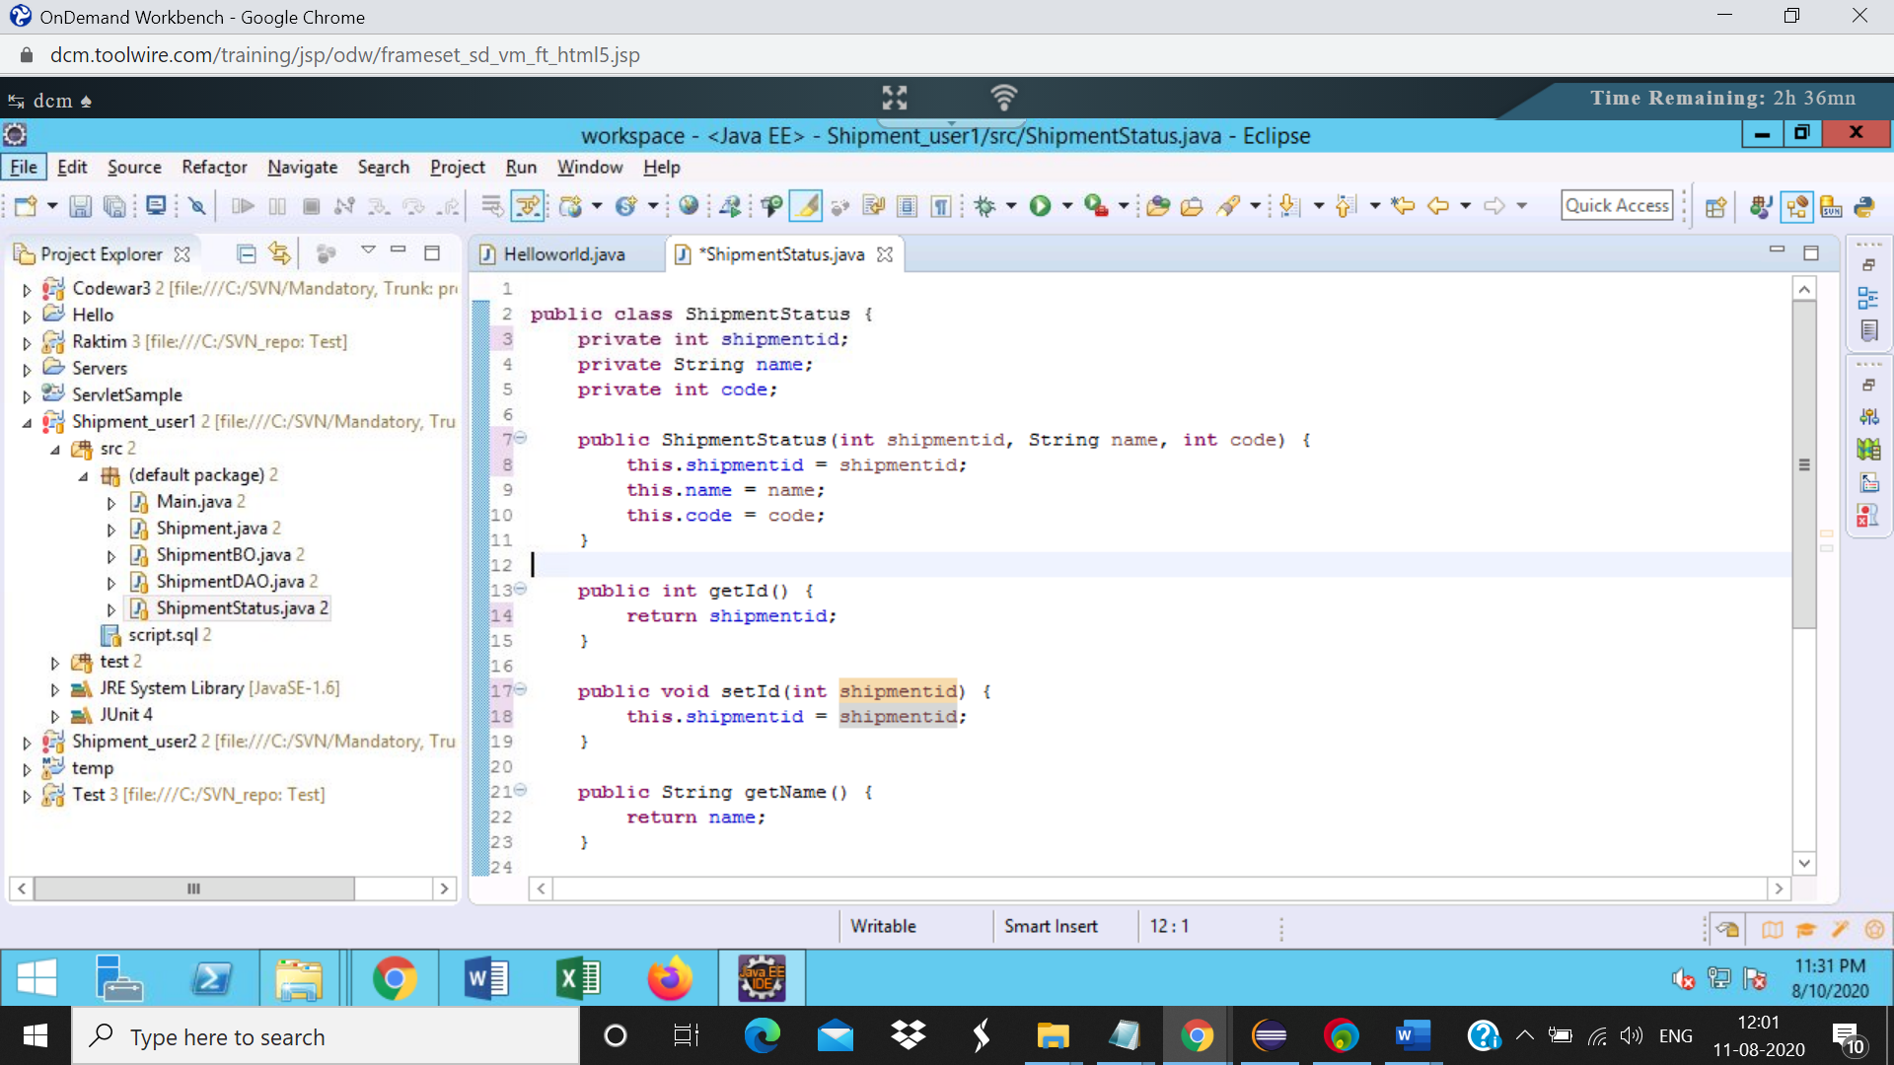

Step8: Right click on the project, select team->commit  
Verify the files in the changes section of the commit dialog. Only the ShipmentStatus.java file should be present

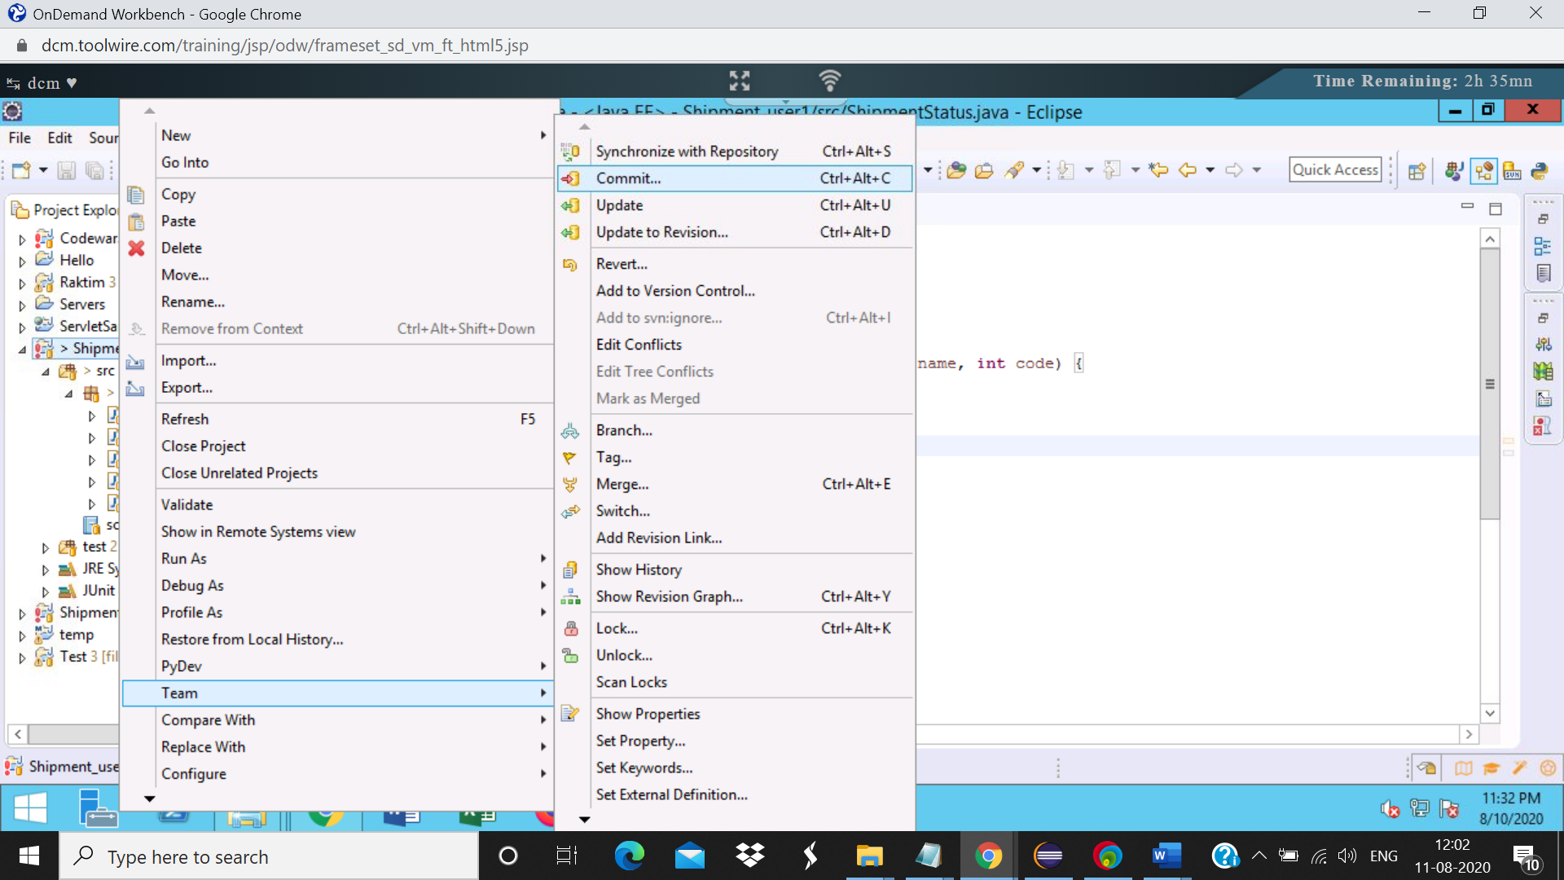

Commit dialog box: Only the shimentstatus.java is present

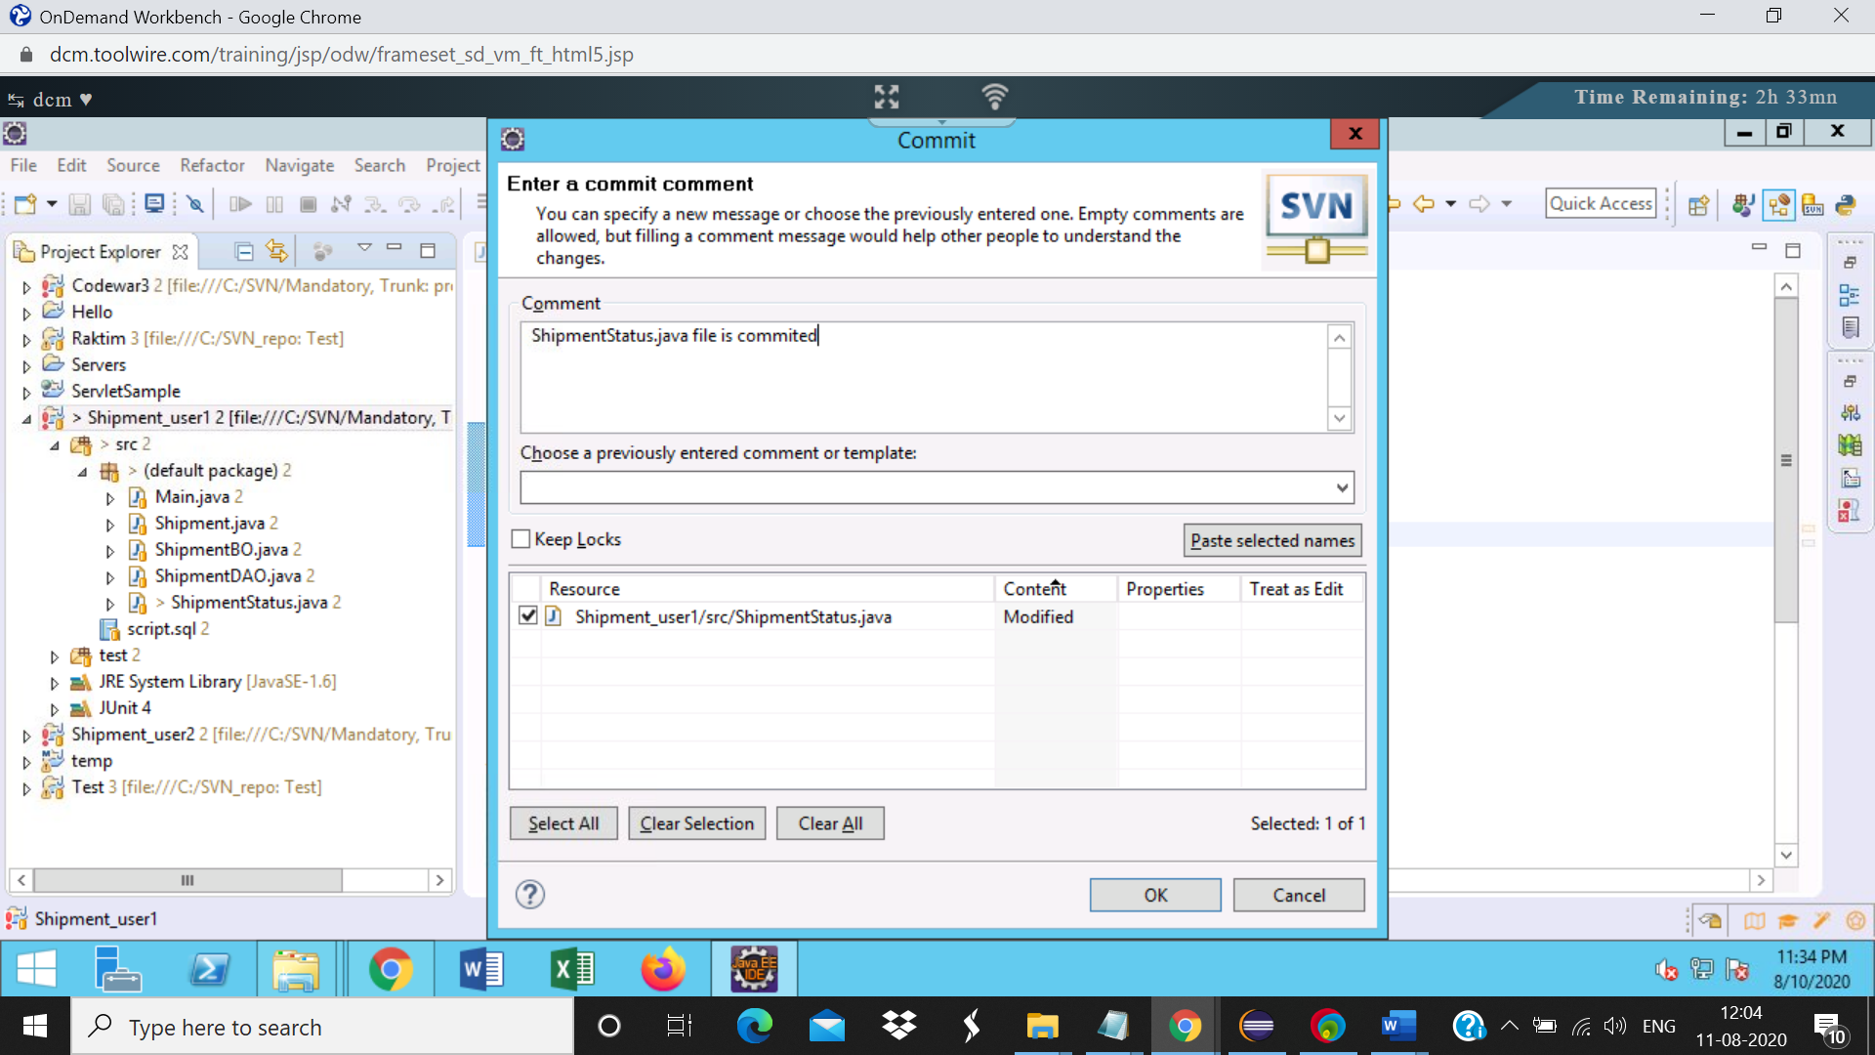

Step10: Shipemt_user2 file is updated

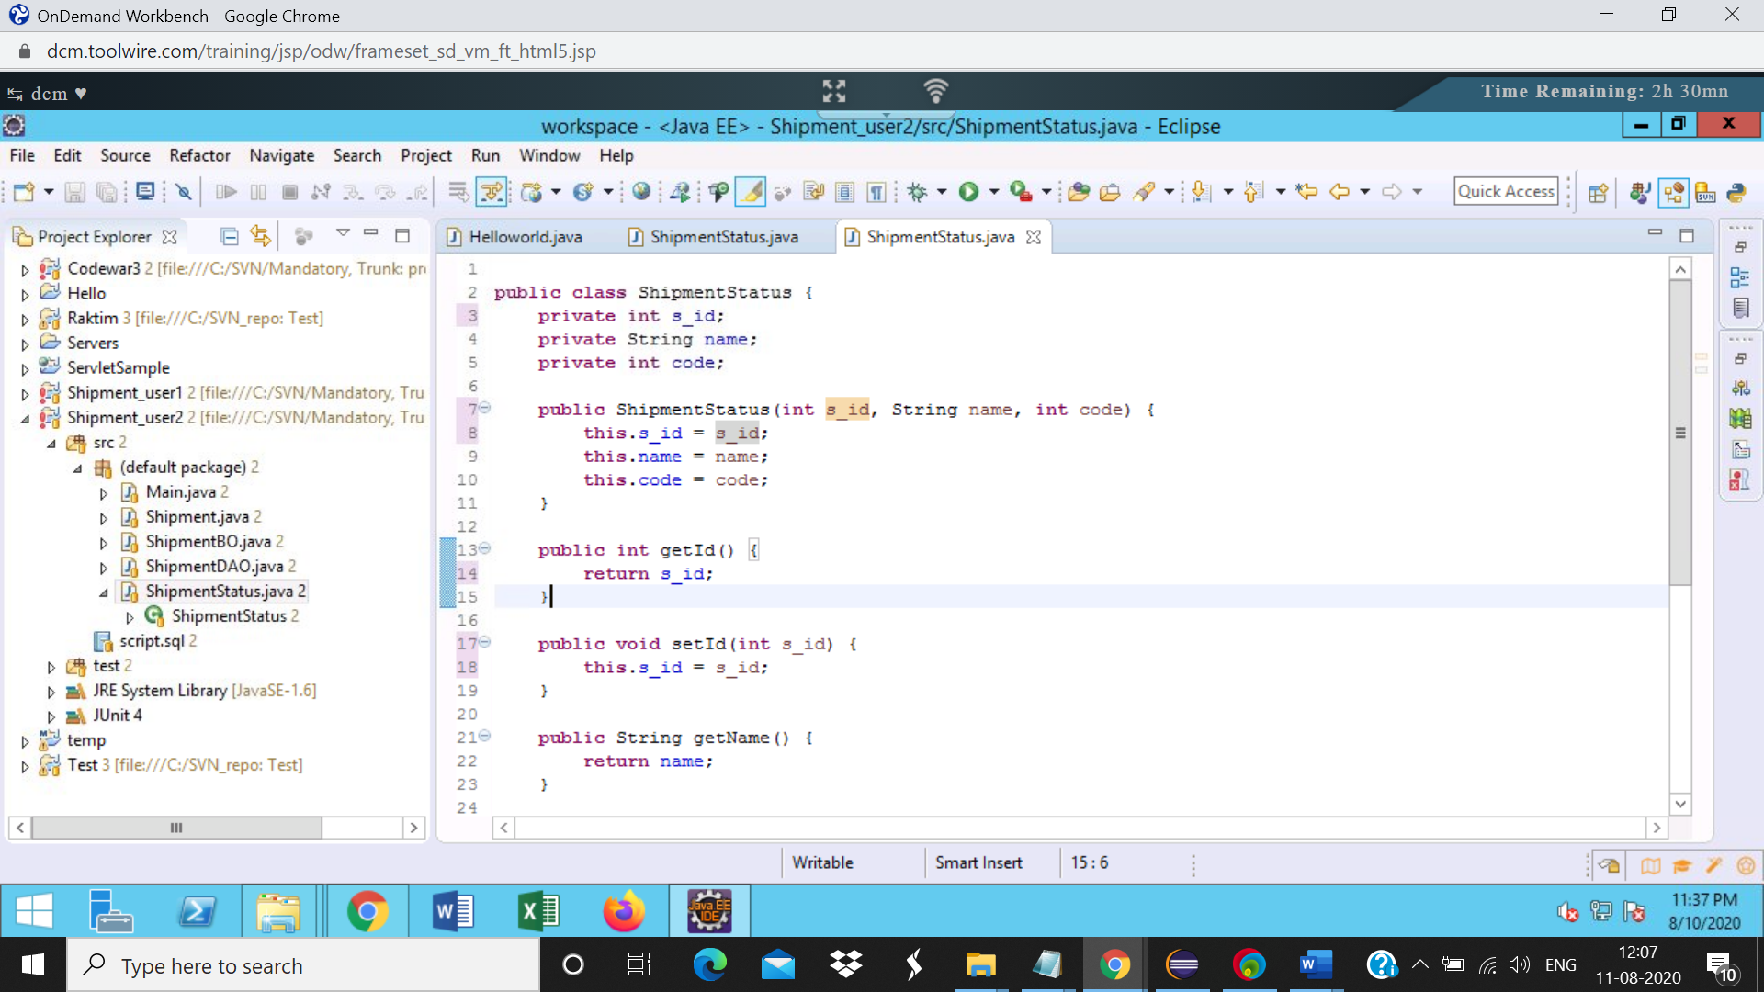

Step11:

Right click on the project,  
select team->update to HEAD.  
The conflicts are present in the project and 3 new files are created with the name:  
*ShipmentStatus.java.mine*  
*ShipmentStatus.java.r<revision no>*  
*ShipmentStatus.java.r<revision no>*

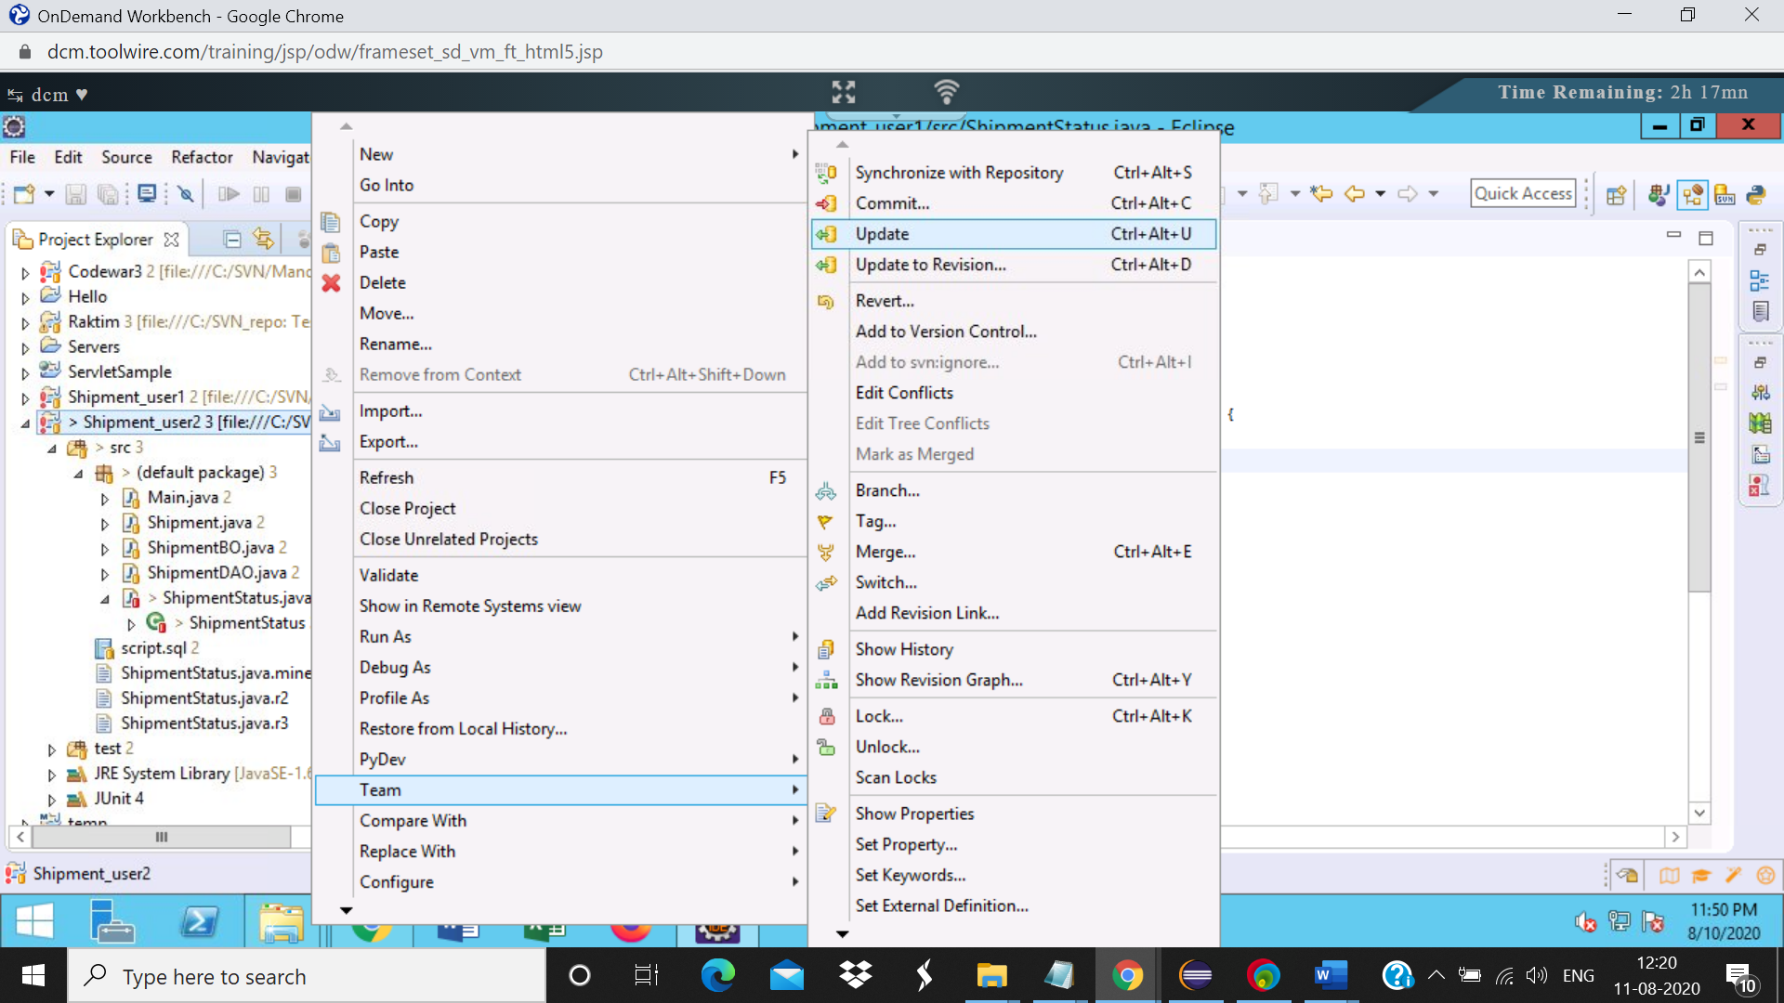

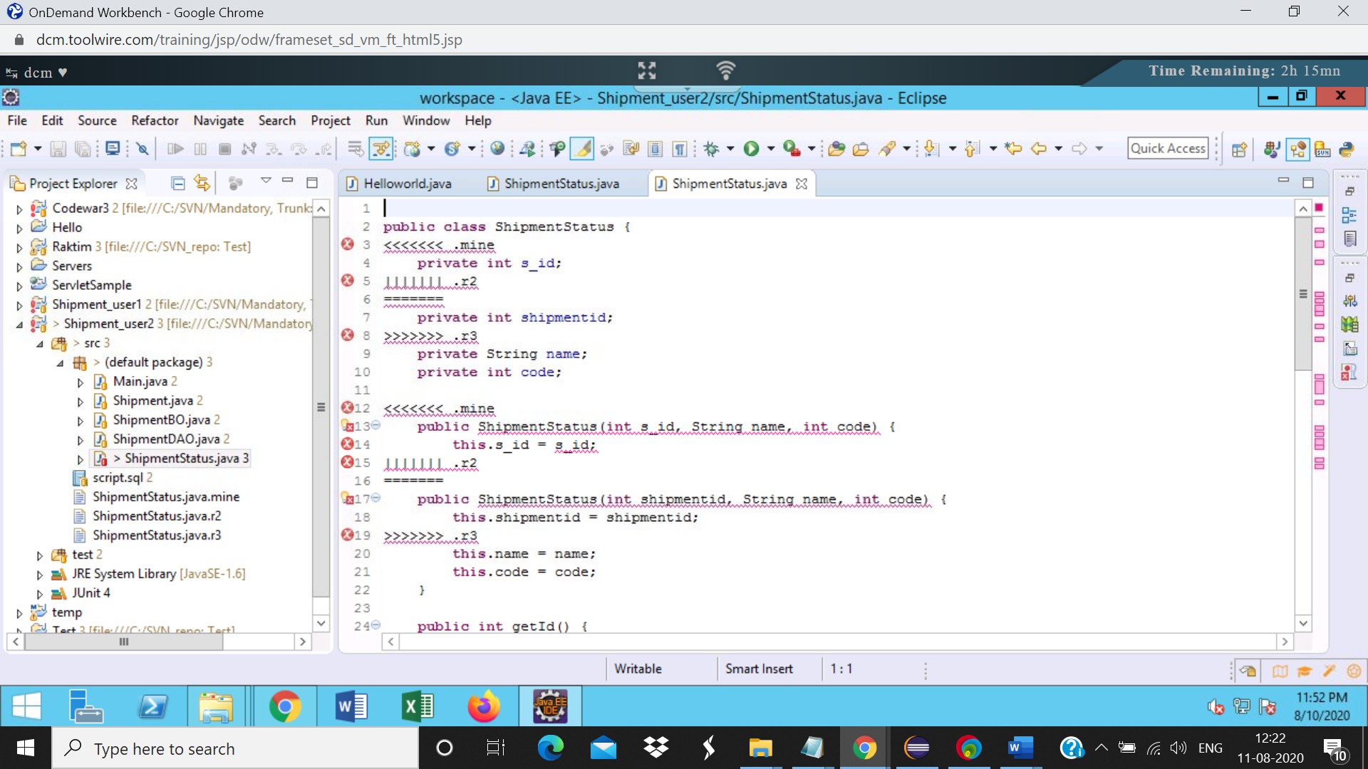

Project explorer view with 3 new files

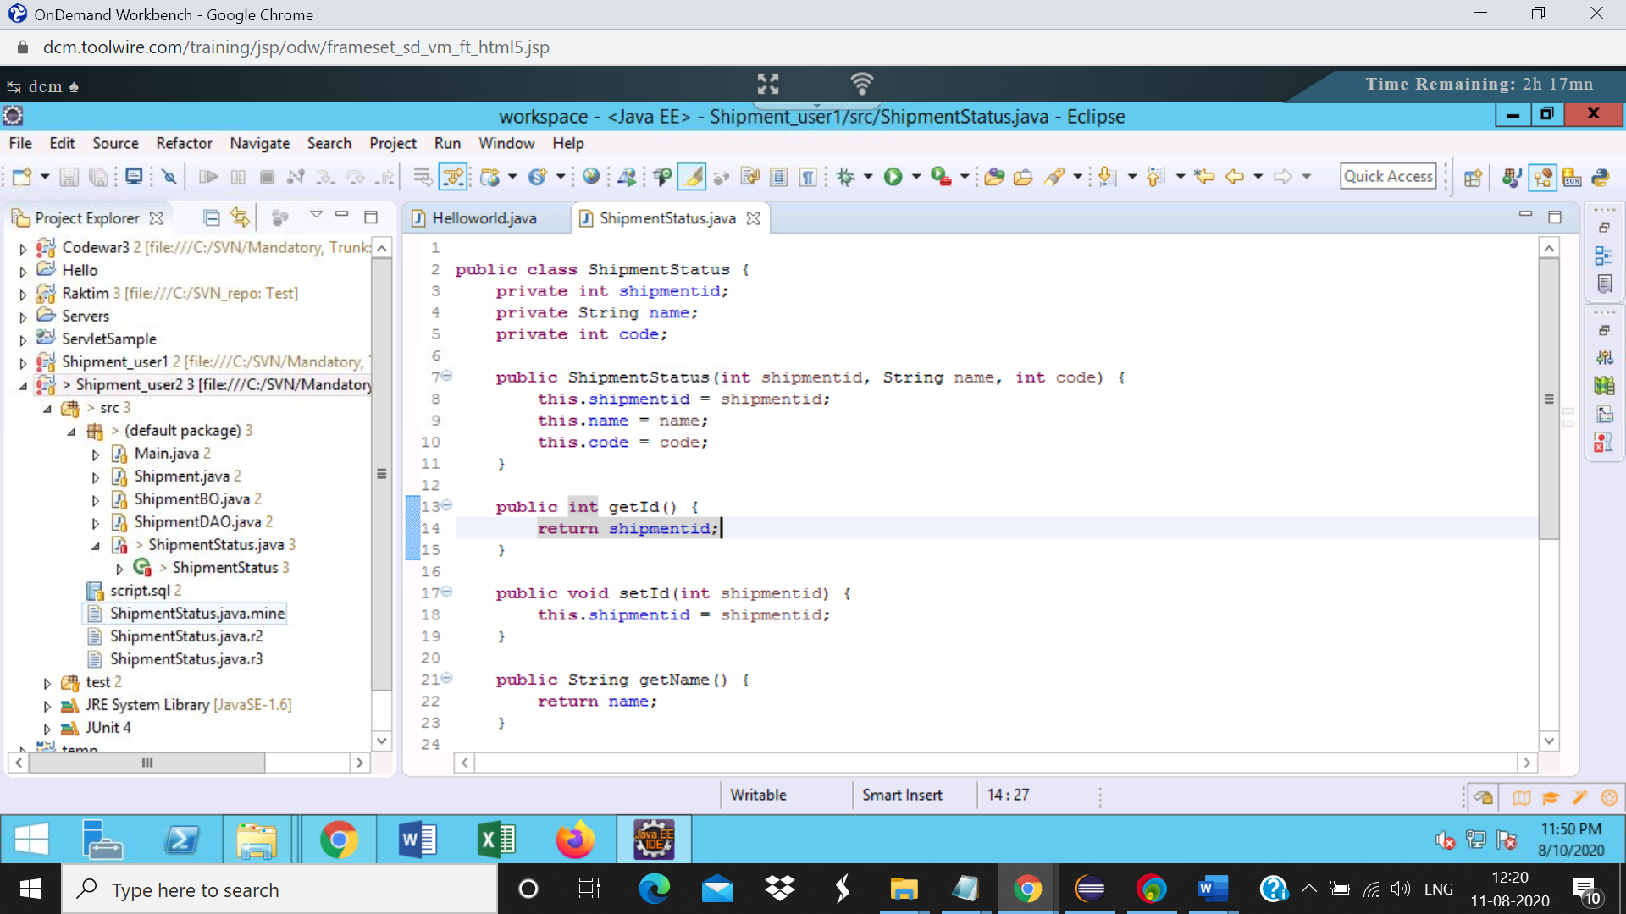

Step12:

Right click on ShipmentStatus, select Team->Mark Resolved

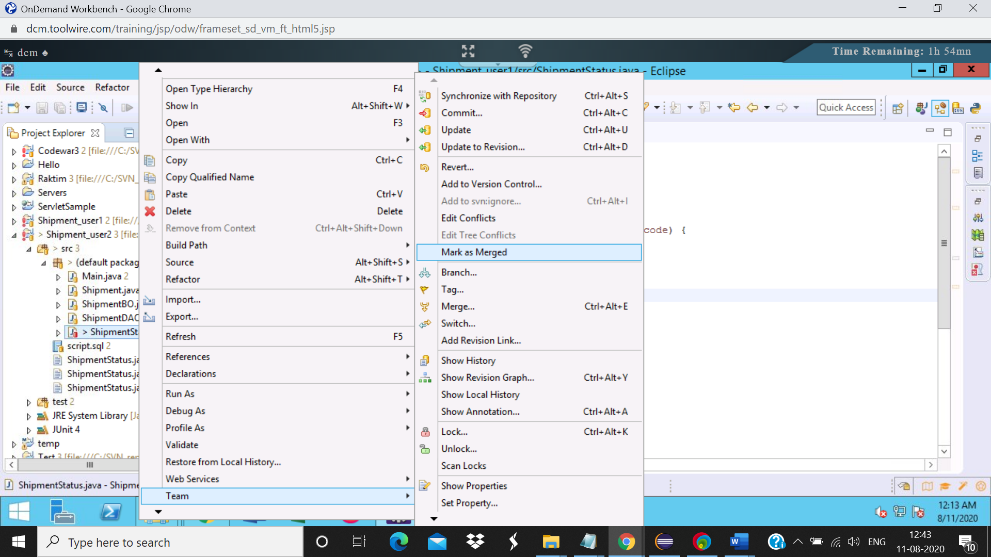

Step13:

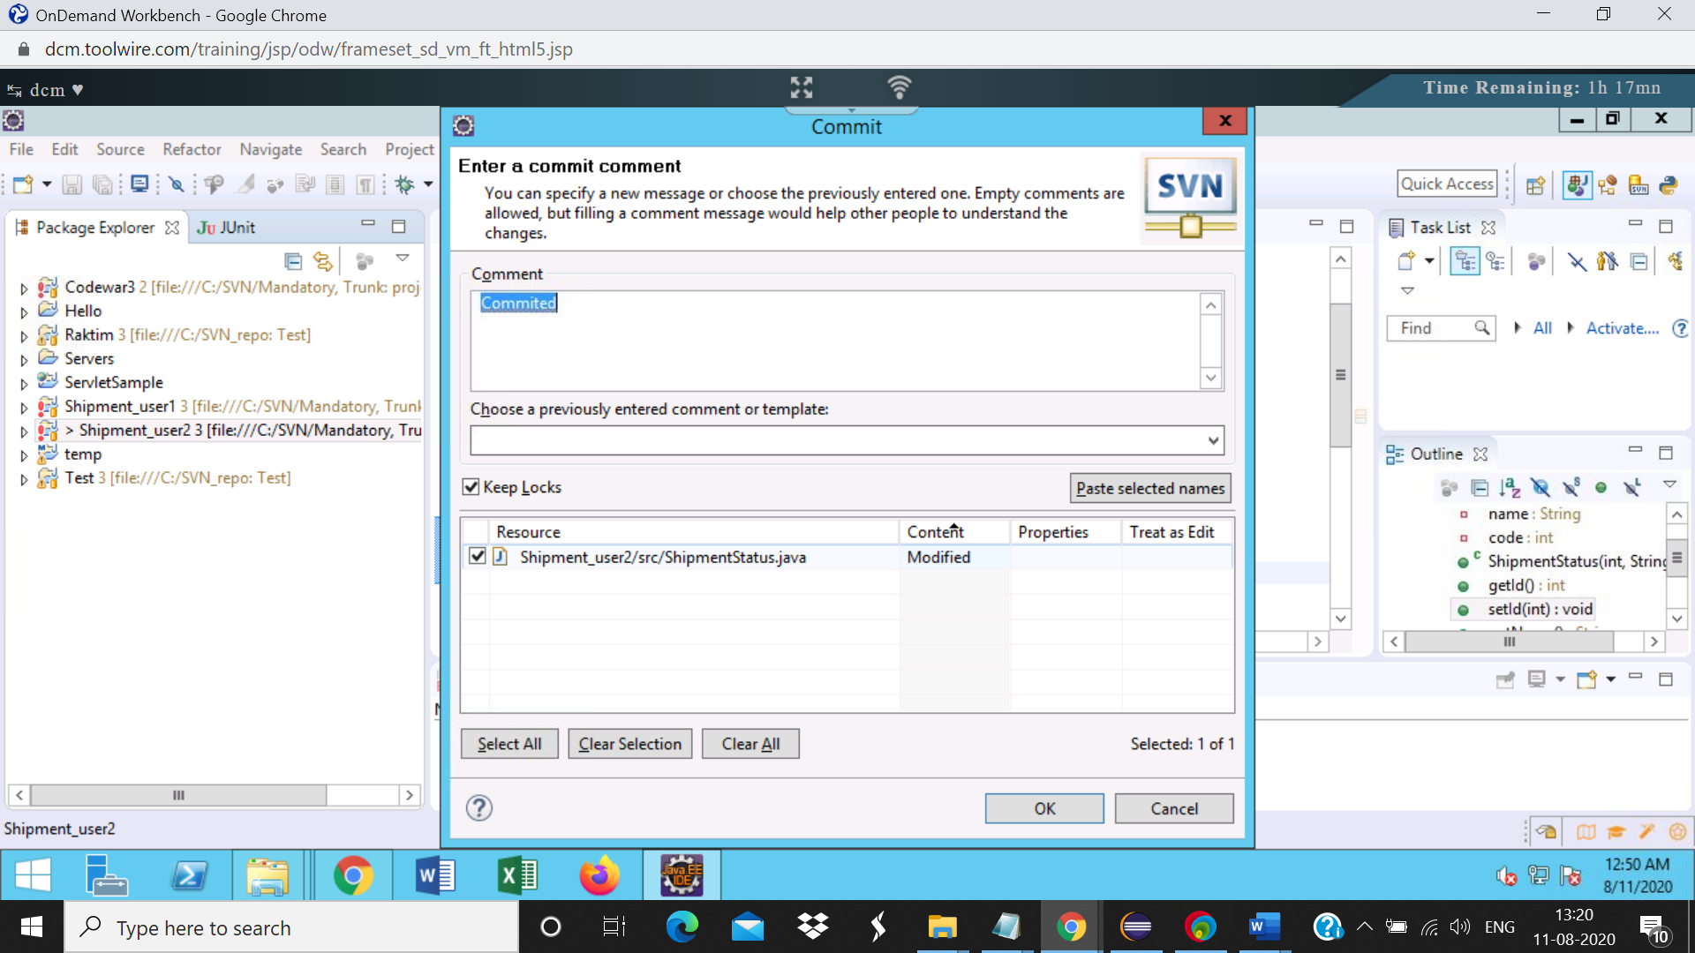

Shipmentstatus file

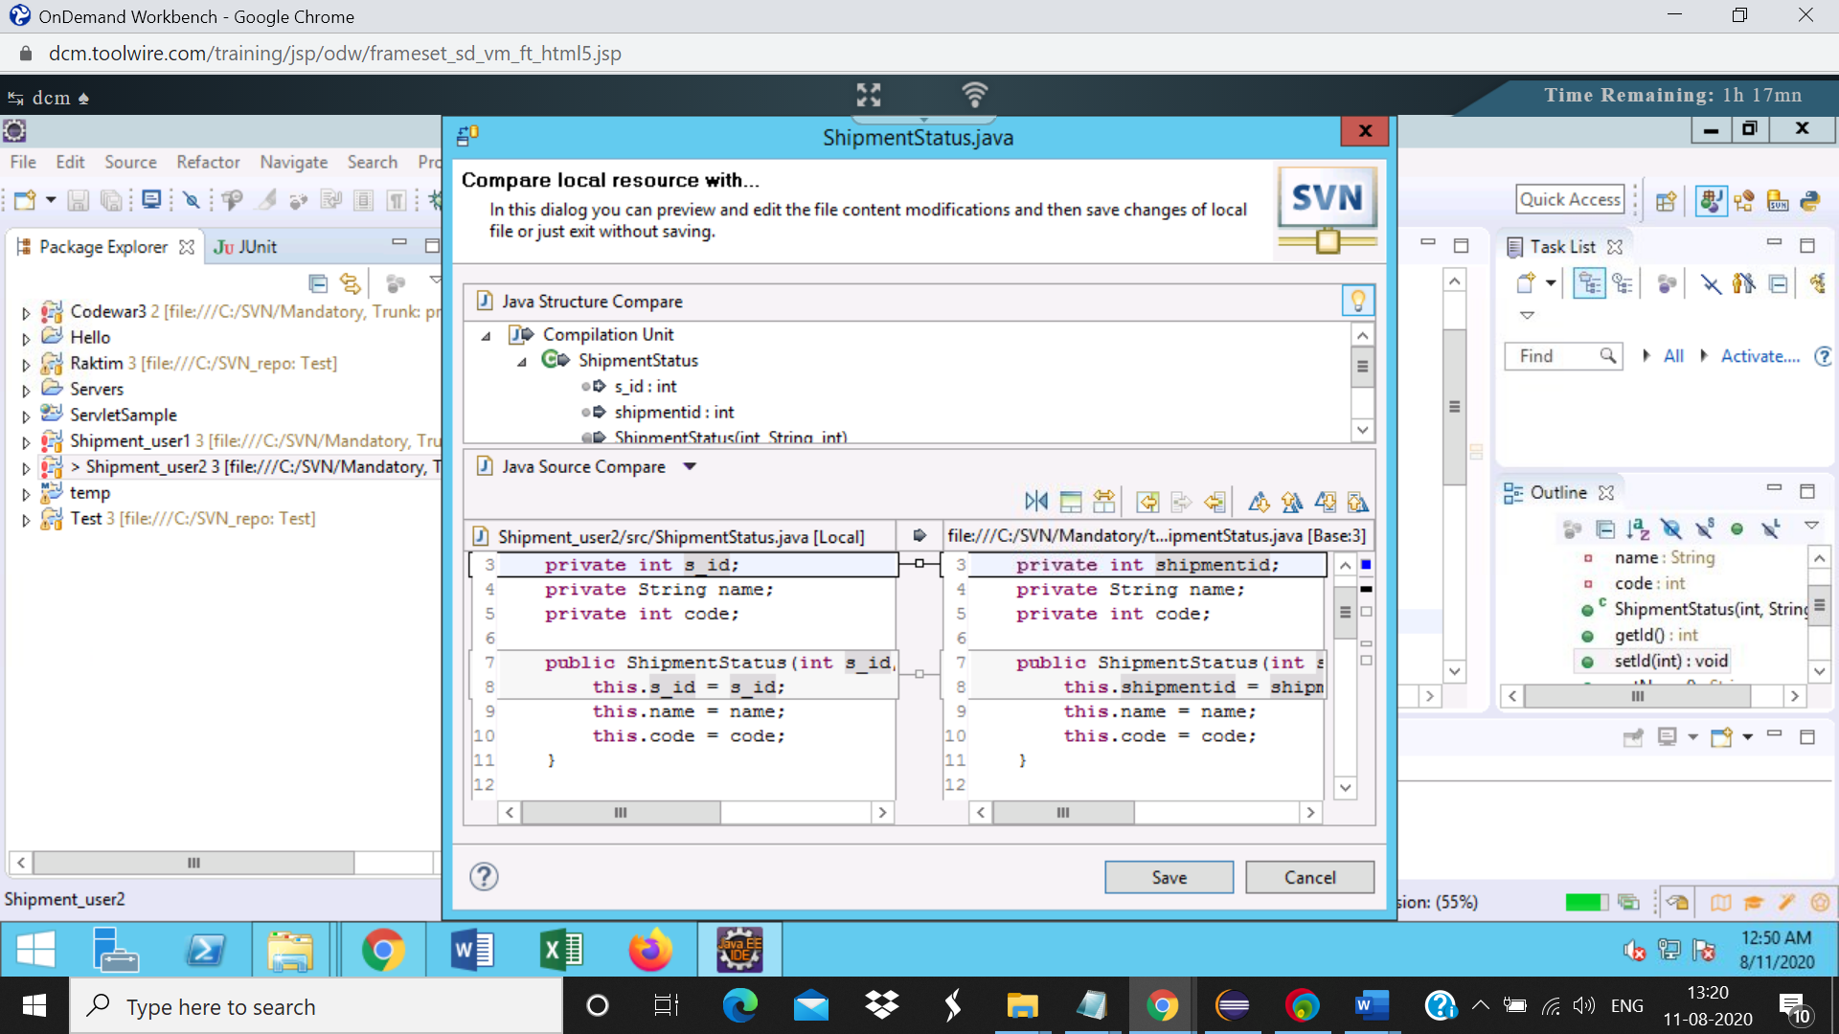

Step14:

